Issue – Angular CLI host is greater than Local host

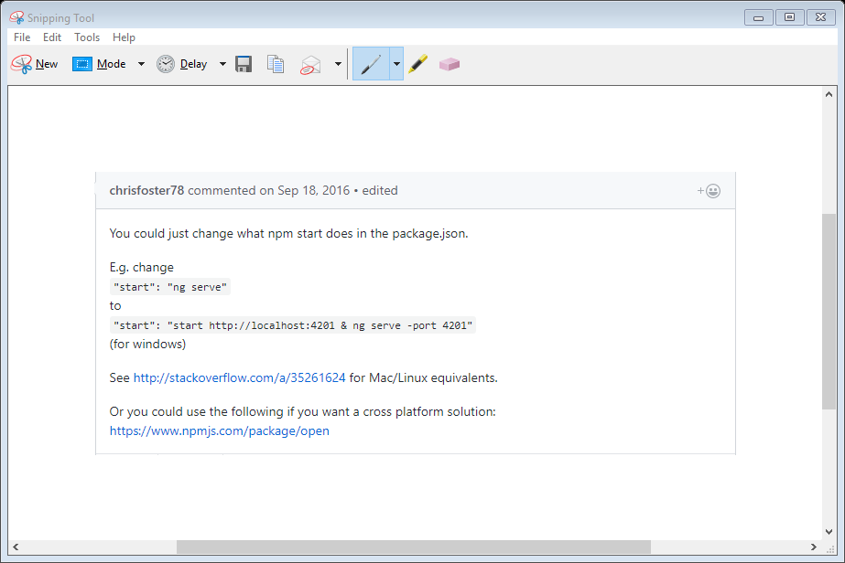

Issue – Bootstrap 🡪 put code in bootstrap.css in node_modules\boostrap\dist\css